|  |  |  |
| --- | --- | --- |
| **Philadelphia Federation of Teachers Health & Welfare Fund & Union** | **Evaluation Requested By**: PFT H&W Fund & Union **Page 1 of** | |
| **Date Inspected**: 12/2/2013 & 12/3  **Initial Inspection?** **☐**  **Follow-Up Inspection?** ☑ | **Inspected by:** Jerry Roseman M.Sc. I.H.  **Others Present? N** on 12/2 & **Y** on 12/3  **Name[s]:** Brian Joseph [on 12/3] |
| **IEQ Evaluation & Inspection Summary Report – Bryant E.S.** | **Date Report Issued**: 12-2-13  **Report Provided To:** Arthur Steinberg, PFTH&W Fund | Photos Attached**: ☑**  Sketches Attached: **☐** |
| **Building Name:** Bryant E.S. **Building Address:** 60th & Cedar Ave **Phone #:**  **Main Contact[s]:** | | |
| **Inspection Overview:** The evaluation was requested by the PFT & conducted in response to major long-term deficiencies in both interior and exterior building conditions leading to significant water/moisture intrusion, with associated mold growth and related health impacts. I inspected Bryant on 12/2 [without OEMS representatives present] and then again on 12/3 with Brian Joseph [KEM-OEMS] present. The school building engineer also participated in the walkthrough.    [1] Inspection of the building exterior & discussions with school staff confirmed that significantly deficient building exterior conditions have not yet been addressed nor did any representatives [e.g. OEMS inspector or Bryant B.E.] have any specific knowledge about or expectation of when exterior repair work would be conducted.  [2] Inspection of the building interior documented the presence of at least four [4] new and/or re-occurring roof leaks at the school – in the IMC; in the New Wing Stairwell; in the Cafeteria; & in the 3rd floor Girls Bathroom - **minor damage to already completed repair work [in the 3rd floor Girl’s Bathroom and in the school Cafeteria] was observed**;  [3] Patching and rough coat re-plastering of mostly minor damage to hallway walls – and to some [all?] bathrooms has been conducted although other interior areas have not yet been addressed. A Maintenance “crew” [#’s and schedule undetermined] has been on-site affecting repairs – necessary work seems to be approximately 10% complete [estimate at school was about 40% but this appeared to be inaccurate] although it was impossible to verify this;  [4] “New” steam leaks were noted to be present in some areas – recently “discovered” [heating “season” is a few weeks old] – contributing to moisture and dampness in occupied building areas and resulting in a secondary source of potential damage to building materials;  **\*\* The inspections conducted on 12/2 and on 12/3 [with OEMS] are not considered as “comprehensive” in identifying all remaining issues and problems** | | |
| |  |  |  | | --- | --- | --- | | **Room –Area Inspected** | **Relevant Observations, Findings & Measurements** | **Comments-Recommendations-Informational Request** | | IMC | “Ongoing” roof leak - where previous leak above damaged plaster ceiling [site of mold growth & major ceiling damage]- water damage to “repaired” ceiling | 1. Assess & evaluate source of ongoing leak and effect roof [and/or other] repairs as necessary;  2. Redo repair to newly damaged ceiling plaster | | New Wing Stairwell – | New – active leak - reported resulting in damage to ceiling materials – [flat roof section above according to the B.E.] | 1. Assess & evaluate source of ongoing leak and effect roof [and/or other] repairs as necessary;  2. Repair damage to ceiling materials | | 3rd Fl. Girl’s Bathroom | Ongoing and active water leak reported – some minor damage observed to already “repaired” ceiling | 1. Assess & evaluate source of ongoing leak and effect roof [and/or other] repairs as necessary;  2. Repair damage to ceiling materials | | Cafeteria | Active water leak reported – evidence of staining, water impact observed – possibly related to roof edge-flashing issues? | 1. Assess & evaluate source of ongoing leak and effect roof [and/or other] repairs as necessary;  2. Repair damage to ceiling materials | | Classroom Areas - Throughout | Walls & ceilings previously scraped & “stabilized” but remain significantly damaged and awaiting repair – no schedule or time frames available | 1. Continue ongoing patch/repair & “finishing” work;  2. Provide schedules, work lists and summaries for accountability, communication & coordination purposes;  3. Provide additional cleaning personnel to effectively control construction dust and debris from work | | Hallway Areas & Bathrooms Throughout | Walls & ceilings previously scraped & “stabilized” & significant plaster patch & repair work conducted | 1. Continue ongoing patch/repair, & “finishing” work;  2. Provide schedules, work lists and summaries for accountability, communication & coordination purposes;  3. Provide additional cleaning personnel to effectively control construction dust and debris from work | | Miscellaneous Areas | Damaged ceiling tiles and materials [reportedly from previous water intrusion events] – including, but not limited to: Stairwell B & IMC Computer room ceilings | 1. Confirm and ensure that active leaking-water intrusion is no longer occurring;  2. Replace damaged/stained ceiling tiles and other building materials as necessary | | Exterior | Problems with masonry, pointing, windows, roofing, etc. still remain and are the major sources of ongoing and continuing water damage and interior moisture and dampness;  Some roof repair and patching work has reportedly occurred but leaks still occurring;  Status of exterior evaluation and condition assessment is unknown | 1. Evaluate exterior conditions as recommended previously and provide summary report;  2. Develop a work plan & schedule to address exterior damage conditions in order to minimize and stabilize impacts associated with ongoing water intrusion;  3. Provide comprehensive information to occupants, stakeholders & others about problem and work scope and schedule | | | |

**Inspection Summary**

**[1] Evaluation Overview -** The 12/2/13 & 12/3 inspections were conducted to follow up on previous evaluations documenting severely deficient, ongoing and repetitive problems related to significantly deteriorated exterior and interior conditions. Reports and information have been available to/from OEMS, FMS and CPO for several years. Following recent assessments conducted on 10/16/13 & 10/24/13, significant interior repair work was [and is being] conducted by SD FMS representatives; unfortunately, however, only very limited exterior work was has been performed, scheduled or discussed [i.e. related to roof repair] - no work has been addressed to exterior masonry, window systems and/or other sources of major water intrusion, leaks, moisture & dampness;

Given the situation at this school, it is critical that discussions about work phasing and schedule occur to ensure cost effective and properly managed remediation

**[2] Roof Leaks** – Roof leaks are still occurring in some areas of the building being documented in areas that had not previously leaked as well as in areas in which past roof leaks had been noted. Some of the areas identified as currently leaking are areas that had been recently “repaired.” Considering the extent, necessity and cost of interior stabilization and repair work, a comprehensive and detailed evaluation of the roof condition and repair needs should be immediately performed

**[3] Steam Leaks –** A few steam leaks were identified at the time of our visits but, since the heating season has just recently gotten underway, further steam trap and related problems may continue to occur. Because these types of steam leaks introduce significant amounts of moisture into the building environment and can severely negatively impact building materials [as well as present a safety hazard to children and adult occupants] an assessment and repair schedule should be conducted and completed as soon as possible.

**[4] Exterior Repair [Masonry and other Building Envelope Issues –** Because of the extent and long-term existence of the exterior problems at Bryant, and the many-year knowledge about these issues by SD FMS & CPO managers a focus on the critical need to develop an interim plan to stabilize the exterior [especially given the nature of the interior work being conducted] is immediately needed. The development of a response plan [perhaps similar in scope and nature to similar work conducted at Blankenburg and other schools] should be undertaken with a focus on identifying worst case areas [e.g. those in the 60th & Cedar street corner or other locations]. FMS and CPO should be aware of, and able to generate a “map” of deteriorated conditions following a 3-5 part “ranking” system and based on exterior visual observation. This characterization can be supplemented by a review of interior damage “mapping” and discussions with building occupants, FMS personnel, work order history, etc.

A response and remediation plan is required to ensure that interior repair are not further compromised

**[5] General Cleaning Issues –** Due to the extent of the repair work throughout the building, significant excess dust is generated by remediation activities. Building cleaning staff is neither properly equipped nor is there adequate manpower to properly clean up from this type of work. Especially given the presence of lead paint [and dust] and plaster dust – asthma triggers and respiratory irritants – the development of a cleaning plan to include wet-wiping/mopping, HEPA-vacuuming and similar is needed;

**[6] IEQ Dashboard Issues -** On the most recent IEQ Dashboard, dated 11/22/13, and provided by OEMS on 12/3, 19 corrective action items were listed for this school; 18 of these items are listed as “closed” and completed by the Maintenance Dept. including the evaluation and repair of the roof. Despite the representations about closed items and lack of any additional items, the conditions noted at this school have persisted for a number of years. This is confirmed by several independent sources of information including the 10/17/11 NIOSH Dampness & Mold Assessment conducted that documented about 95% of all school areas with at least some water damage, mold and/or other moisture related impacts, none of which appeared on the IEQ Dashboard or was effectively addressed prior to the incident that occurred in September of 2013. There should be a further review and discussion of the IEQ Dashboard as a useful tool for the tracking of ongoing status and open and closed corrective actions and needs.

**[7] Information Sharing**

* All reports, summaries and information related to remediation should be provided to PFT H&W Fund/Union representatives & building occupants in a timely and ongoing manner;

**PHOTO LOG -** **Selected & Representative** **Photos**

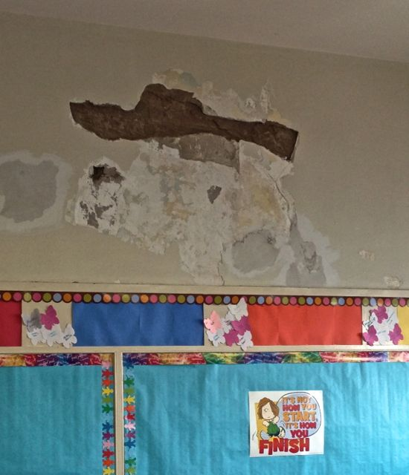

**Bryant E.S. – 12/3/13 - 3rd Floor Classroom [302] – currently existing condition**

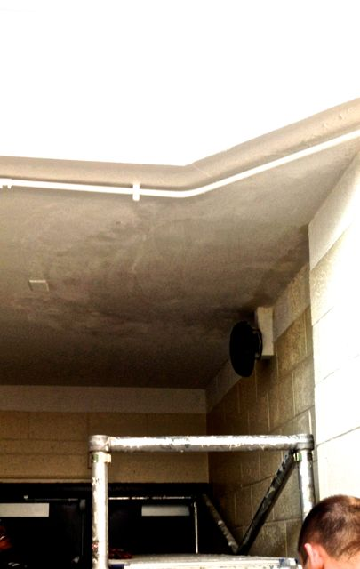

**Bryant E.S. – 12/3/13 – IMC – New Patch near exit door – Active Leak [repeat]**

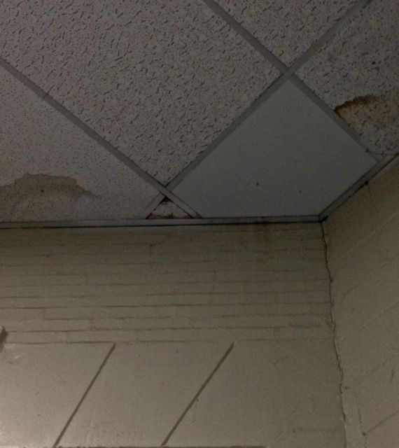

**Bryant E.S. – 12/3/13 – Water stained/damaged Ceiling Tiles – Roof Leak**

**Executive Summary – Bryant E.S. Evaluations – 12/2 & 12/3**

**[1]** Follow-up evaluations were conducted at Bryant E.S. on 12/2/13 and again on 12/3/13

**Evaluation Overview -** The 12/2/13 & 12/3 inspections were conducted to follow up on previous evaluations documenting severely deficient, ongoing and repetitive problems related to significantly deteriorated exterior and interior conditions. Reports and information have been available to/from OEMS, FMS and CPO for several years. Following recent assessments conducted on 10/16/13 & 10/24/13, significant interior repair work was [and is being] conducted by SD FMS representatives; unfortunately, however, only very limited exterior work was has been performed, scheduled or discussed [i.e. related to roof repair] - no work has been addressed to exterior masonry, window systems and/or other sources of major water intrusion, leaks, moisture & dampness;

Given the situation at this school, it is critical that discussions about work phasing and schedule occur to ensure cost effective and properly managed remediation

**[2] Roof Leaks** – Roof leaks are still occurring in some areas of the building being documented in areas that had not previously leaked as well as in areas in which past roof leaks had been noted. Some of the areas identified as currently leaking are areas that had been recently “repaired.” Considering the extent, necessity and cost of interior stabilization and repair work, a comprehensive and detailed evaluation of the roof condition and repair needs should be immediately performed

**[3] Steam Leaks –** A few steam leaks were identified at the time of our visits but, since the heating season has just recently gotten underway, further steam trap and related problems may continue to occur. Because these types of steam leaks introduce significant amounts of moisture into the building environment and can severely negatively impact building materials [as well as present a safety hazard to children and adult occupants] an assessment and repair schedule should be conducted and completed as soon as possible.

**[4] Exterior Repair [Masonry and other Building Envelope Issues –** Because of the extent and long-term existence of the exterior problems at Bryant, and the many-year knowledge about these issues by SD FMS & CPO managers a focus on the critical need to develop an interim plan to stabilize the exterior [especially given the nature of the interior work being conducted] is immediately needed. The development of a response plan [perhaps similar in scope and nature to similar work conducted at Blankenburg and other schools] should be undertaken with a focus on identifying worst case areas [e.g. those in the 60th & Cedar street corner or other locations]. FMS and CPO should be aware of, and able to generate a “map” of deteriorated conditions following a 3-5 part “ranking” system and based on exterior visual observation. This characterization can be supplemented by a review of interior damage “mapping” and discussions with building occupants, FMS personnel, work order history, etc.

A response and remediation plan is required to ensure that interior repair are not further compromised

**[5] General Cleaning Issues –** Due to the extent of the repair work throughout the building, significant excess dust is generated by remediation activities. Building cleaning staff is neither properly equipped nor is there adequate manpower to properly clean up from this type of work. Especially given the presence of lead paint [and dust] and plaster dust – asthma triggers and respiratory irritants – the development of a cleaning plan to include wet-wiping/mopping, HEPA-vacuuming and similar is needed;

**[6] IEQ Dashboard Issues -** On the most recent IEQ Dashboard, dated 11/22/13, and provided on 12/3, 19 corrective action items were listed for this school; 18 of these items are listed as “closed” and completed by the Maintenance Dept. including the evaluation and repair of the roof. Despite the representations about closed items and lack of any additional items, the conditions noted at this school have persisted for a number of years. This is confirmed by several independent sources of information including the 10/17/11 NIOSH Dampness & Mold Assessment conducted that documented about 95% of all school areas with at least some water damage, mold and/or other moisture related impacts, none of which appeared on the IEQ Dashboard or was effectively addressed prior to the incident that occurred in September of 2013. There should be a further review and discussion of the IEQ Dashboard as a useful tool for the tracking of ongoing status and open and closed corrective actions and needs.

**[7] Information Sharing**

* All reports, summaries and information related to remediation should be provided to PFT H&W Fund/Union representatives & building occupants in a timely and ongoing manner;